Statement of Work

to engage DevOps

LEARNT Global

07 Nov 2023



**Copyright Information**

This document is the exclusive property of Happiest Minds Technologies Ltd. (“Happiest Minds”). The recipient agrees that they may not copy, transmit, use, or disclose the confidential and proprietary information in this document by any means without the expressed and written consent of Happiest Minds. By accepting a copy, the recipient agrees to adhere to these conditions to the confidentiality of Happiest Minds practices and procedures.

**Confidentiality Clause**

This document is being submitted to LEARNT Global by Happiest Minds Technologies Ltd. on the understanding that the contents of this document will not be divulged to any third party without the express written consent of the parties. It is also understood that the parties will not divulge any confidential information about LEARNT Global that it may have access to during this interaction.

**Disclaimer**

This document has been prepared based on the information provided by LEARNT Global. Wherever proposed, the solutions and/or services mentioned are based on the requirements defined and understood by us at the time of preparing this document. While every effort has been made to make this document as accurate as possible, there might be changes to the document based on the subsequent discussions. ￼

Table of Contents

1. Purpose 4

2. Executive Summary 4

3. Requirement Details 4

3.1 Our Understanding of Requirements 4

3.2 In Scope 4

3.3 Out of scope 5

3.4 Assumptions 5

3.5 Dependencies on LEARNT Global 5

4 DevOps Solution Consideration 6

4.1 DevOps Approach 6

4.2 DevOps CI/CD 7

4.3 Branching strategy 9

4.4 Release Process 9

4.5 DevOps Cloud Security for Application 10

4.6 Application and Infrastructure Monitoring 10

5 Project Delivery Approach 10

5.1 Governance Model 12

5.2 Project Communication Model 12

5.3 Risk and Mitigation Plan 12

5.4 Execution Schedule and Deliverables 12

5.5 Change Request Management 13

5.6 Acceptance Criteria 14

6 Commercials 14

6.1 Hourly Rate 14

6.2 Payment Terms 14

6.3 Commercial terms and conditions 14

7 GENERAL LEGAL TERMS AND SOW ACCEPTANCE 15

8 Contact Information 15

9 TERMINATION 16

# Purpose

This Statement of Work (SOW) dated 7th November 2023 (Effective Date) is entered by and between

Happiest Minds Technologies Limited (formerly known as Happiest Minds Technologies Private Limited), a public limited company incorporated under the provisions of the Companies Act, 1956, and having its registered office at #53/1-4, Hosur Main Road, Madivala (Next to Madivala Police Station), Bangalore-560068, Karnataka, India and branch office at Level 20, Tower 2, Darling Park, 201, Sussex Street, Sydney, NSW 2000, Australia (“Happiest Minds”) (“Vendor”)

and

Learnt Global Pty Ltd., having its office at Level 4, Suite 402, 441-449 Elizabeth Street, Surry Hills NSW 2010 Australia (“Learnt Global” or “Client”)

The purpose of this document is to detail the Scope for **“Learnt Global DevOps Requirement”** as specified below.

# Executive Summary

Happiest Minds Technologies would like to thank LEARNT Global for giving us this opportunity to submit our proposal for DevOps Engagement for LEARNT’s client. We also thank the LEARNT Global team for providing us with clarifications as we went through the proposal preparation process.

LEARNT Global intends to build the Environment for Developers to spin up the Docker container on their machine for Development purpose.

Happiest Minds considers it our privilege to bid for this opportunity from LEARNT Global. We believe we are best placed to be your partner of choice. We believe we have addressed your requirements and your expectations through this proposal. We believe that we would be the right partner for LEARNT Global for this initiative. We look forward to partnering with LEARNT Global on this engagement.

# Requirement Details



## Our Understanding of Requirements

LEARNT Global intends to build the Environment for Developers to spin up the Docker container on their machine for Development purpose and Separate Jenkins Job to run the CloudFormation Template to rebuilds the required Environment.

## In Scope

* Discussion with the Product owners and the team at LEARNT to understand the context, needs to be able to empathize with users and their needs.
* Study documentation which will be provided by the LEARNT team and seek clarifications as required.
* Collaborate with LEARNT and define the approach based on the scope and understanding gained which would require grouping of tasks for planning design sprints and task prioritization.
* Present the DevOps Approach scoped for a sprint and iterate as per the feedback.
* Docker Container deployment for microservices.
* Setting up CI/CD for both application/microservices deployment and Infrastructure configuration.
* Configuration of CloudFront for UI.
* Docker Volume binding.
* Documentation and Handover.

## Out of scope

* Orchestration tools/Cluster configuration.
* Atlassian JIRA setup and configuration.
* Database configuration setup and existing Database backup.

## Assumptions

* The application follows a microservices or monolithic architecture, where different services or components can be containerized using Docker. The proposal focuses on the **deployment and management of these containers**.
* The infrastructure will be hosted on Amazon Web Services (AWS) and utilizes AWS services such as **IAM, Secrets Manager, CloudFormation, S3, VPC, Load Balancer, WAF, CloudWatch etc.** It takes into account the specific features and capabilities offered by AWS for managing the infrastructure.
* Final Infrastructure configuration will be decided by LEARNT or by mutual discussion.
* The presence of an existing CI/CD (Continuous Integration/Continuous Deployment) pipeline. It suggests integrating **Jira, Bitbucket, and Jenkins** but does not provide details on the current setup or configuration.
* **Learnt Global** suggests setting up a PHP 8.0 environment within Docker Image, installing necessary extensions, and monitoring PHP versions and security updates.
* Implementing IAM roles and policies, security group configurations, NACL rules.
* Docker security features, secure coding practices, and secure storage of secrets in AWS Secrets Manager.
* Docker Hub supports an automatic vulnerability scanning feature, which when enabled automatically scans images when we push them to a Docker Hub repository.
* Assuming LEARNT already using **Sonar** for Code quality and analysis, will use and integrate the same on this pipeline.
* Docker License will be taken care by Learnt Global.
* Existing application user’s permissions will be integrated with AWS IAM.
* Any other paid tools/licenses will be taken care by Learnt Global.
* Existing Docker file will be provided Learnt Global.

## Dependencies on LEARNT Global

* Learnt Global must provide access to their **AWS account**, including appropriate permissions for creating and managing AWS resources and other tool access to Jenkins, JIRA, Bitbucket, Docker Hub and other tools.
* **LEARNT** shall help us for providing the application code and configuration files. This includes the PHP application code, nginx configurations, database configurations, and any other relevant configuration files required for the application to run.
* Integrating Jira with other tools like Bitbucket and Jenkins. **LEARNT** would need to ensure that the proposed workflow aligns with their existing processes and tools.
* LEARNT should communicate any specific security requirements or compliance standards that need to be followed. This information is important for implementing appropriate security measures, access controls, encryption, and other security-related aspects mentioned in the proposal.
* The turnaround time for a review and **receiving feedback is estimated to be a max of 48 hrs**. upon design artifact submission by Happiest Minds.

# DevOps Solution Consideration

## DevOps Approach

The proposed deployment approach is integrated with the existing Learnt Global System/platform.  Continuous Integration and Continuous Deployment are configured with the existing tools.

The diagram below and the table below gives the details about the tools.

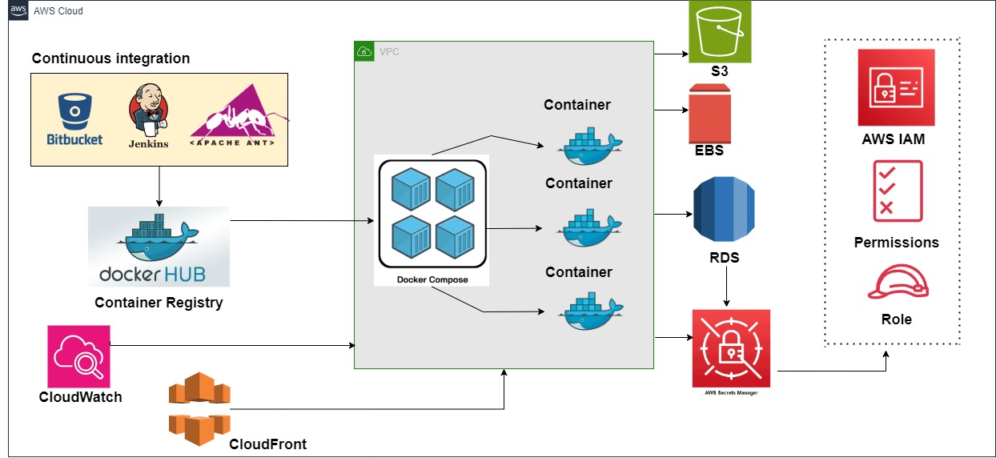

|  |  |
| --- | --- |
| **Tools** | **Description** |
| Docker Compose | Utilize Docker Compose for local development environments as well as deploying to AWS.  Set up a docker-compose.yml file with configurations for services like nginx, PHP, and databases.  Use volume mappings to reflect local code changes within the Docker containers.  Leverage Docker Hub for hosting Docker images. |
| IAM (Identity and Access Management) | Implement IAM roles and policies to manage access and permissions for different users and services.  Assign appropriate IAM roles to individuals based on their responsibilities and access requirements. |
| AWS VPC | Design and configure a secure VPC architecture to isolate your application from the public internet.  Set up private and public subnets, route tables, and network access control lists (ACLs) to control inbound and outbound traffic.  Implement security groups to enforce network-level security. |
| Docker Hub | Docker images are created to run for the containers to be deployed on Docker platform. We use Docker Hub centralized storage for configuring and uploading the docker images of non-prod and prod environments. |
| AWS CloudFormation | The infrastructure will be defined as code using AWS CloudFormation, enabling consistent and repeatable provisioning of AWS (Amazon Web Services) resources. This approach ensures the entire infrastructure is version-controlled, allows for easy tracking of changes, and simplifies collaboration. |
| Cloud Watch | Cloud watch is centralized and configured in the region for extracting and maintaining the logs. |
| New Relic | New Relic's Docker monitoring quick start empowers you to get a 360° visibility for your apps, server infrastructure, and Dockerized containers—all in one place. |
| AWS S3 | S3 bucket can be used to host the static website and to store the application processed Documents, images, and reports. |
| AWS WAF | AWS Web Application Firewall (WAF) or a third-party Web Application Firewall to protect against common web vulnerabilities and attacks. |
| AWS RDS | It enables you to set up, operate, and scale a relational database in the cloud without needing to manage the underlying infrastructure.  With AWS RDS, there are options to choose from various database engines, including Amazon Aurora, MySQL, PostgreSQL, Oracle Database, and Microsoft SQL Server. RDS takes care of routine database administration tasks such as backups, software patching, and automatic scaling. |
| AWS Secret Manager | AWS Secrets Manager is a service provided by Amazon Web Services (AWS) that helps to protect sensitive information such as API keys, database credentials, and other secrets. It enables you to securely store, manage, and retrieve secrets for your applications and services. |
| JIRA | Jira for managing the Agile process and tracking project progress. |

## DevOps CI/CD

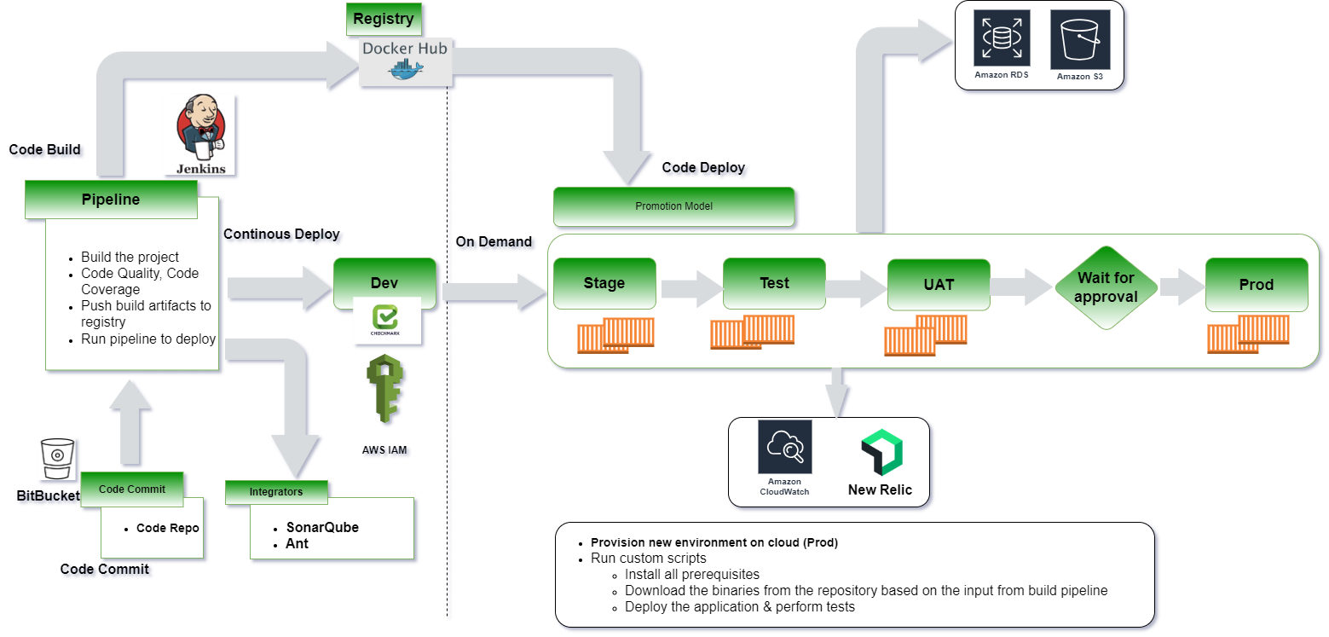

The following are the steps execution as part of the pipeline the CICD pipeline is configured with all the requirement stages for the build execution:

* CICD Pipeline is configured with multi-stage build process for the pipeline build execution.
* Continuous Integration of the build process starts and triggers the staged build process.
* The triggered build process on compilation is successful proceed with the next gated check with the code quality.
* During the process, the image is validated for all the security integration with the scanning using the tool.
* The image of having the vulnerability criteria falls into criteria like high, medium, and low grouping.
* The rules are being set with the expectation for the code to be passed in and to upload on to the Registry.
* On successful compilation the build is uploaded onto the Container Registry.
* The artifact is then called using the Continuous Integration process for the artifact deployment onto the Docker Environment.

For continuous integration and continuous deployment (CI/CD), we will utilize the following tools and practices:

* **Code repository**: Bit Bucket for version control and collaboration.
* **Code Quality**: SonarQube (formerly Sonar) is an open-source platform for continuous inspection of code quality to perform automatic reviews with static analysis of code to detect bugs.
* **Build and dependency management**: ANT or any existing build tool for building the application.
* **Containerization**: Docker will be used to containerize the Application.
* **Docker Image Scanner**: Docker Hub automatically scans the image to identify vulnerabilities.
* **Container Registry**: DockerHub will be used to store and manage Docker images.
* **Continuous Integration and Deployment**: Jenkins will be used to establish a robust CI/CD pipeline. It will integrate with the version control system to trigger automated builds/manual triggers, perform code quality checks and deploy the applications to the Docker Environment. Jenkins pipelines will be defined using declarative syntax for easy maintenance and scalability.
* **Infrastructure Updates**: Infrastructure updates will be handled using CloudFormation, triggered by the Jenkins CI/CD pipeline.

## Branching strategy

**Proposed Flow**:

* Standard conventions are followed for the branching strategy so that the product is uniquely identified.
* The feature branches are short lived branches which are being developed and merged into the development branches with Pull requests and approvals.
* The development branches are then merged on to the supporting branches called the Release branches.
* Tags are being created from the branches to do the releases.
* The release is then tagged based on the short outcomes of the releases.
* Finally approved changes are being merged back into the Master branch and the deployment happens from this branch.
* The master branch is then again branched out for the latest changes in development/feature to worked upon by developers.

The hotfix branches are created in case of any critical issues to be fixed on the production release being done from the master branch.

## Release Process

* The release process will be created with the managers & cab approval obtained prior to the releases.
* Release processes are defined with the CI/CD Integrated
* Deployment will be done through the build tool.
* Frequent branches and the tagging process will be created for the deployment.
* Release will be tagged and stored as a Tag in the Repo.
* Hotfix branches will be created during the process of any critical fixes that need to be part of the deployment.
* Communicate to the Stake holders on the release complete
* The Release will be deployed using the pipeline with the specific branching Tag created for the deployment.
* The Releases will be version controlled and deployed from the specific pipeline.
* The promotion of artifacts/Docker images will be done using pipelines.

## DevOps Cloud Security for Application

* Separate VPC will be configured and deploy the microservices and application in private subnet.
* Security group Rules for the private and public configured.
* Access Identity and Management (IAM) Access Analyzer.
* Docker Hub supports an automatic vulnerability scanning feature, which when enabled automatically scans images when we push them to a Docker Hub repository.
* Secrets Manager that helps to securely store, manage, and retrieve secrets for your applications and services.
* Security assessments on the NACL rules & configuration.
* Configuring the right access to the corresponding repos, S3 and other services.
* Software upgradation and other security patches installation will be taken care.

## Application and Infrastructure Monitoring

* Configure monitoring tools like New Relic, AWS CloudWatch to gain insights into the performance and health of the infrastructure and applications.
* Set up monitoring alerts, dashboards, and anomaly detection to proactively identify and resolve issues.
* Monitor key metrics such as CPU usage, memory utilization, response times, and error rates.

# Project Delivery Approach

Agile Scrum framework would be used for project execution. Scrum ensures transparency in communication and creates an environment of continuous progress. The below diagram depicts the model followed by Happiest Minds in Agile projects.

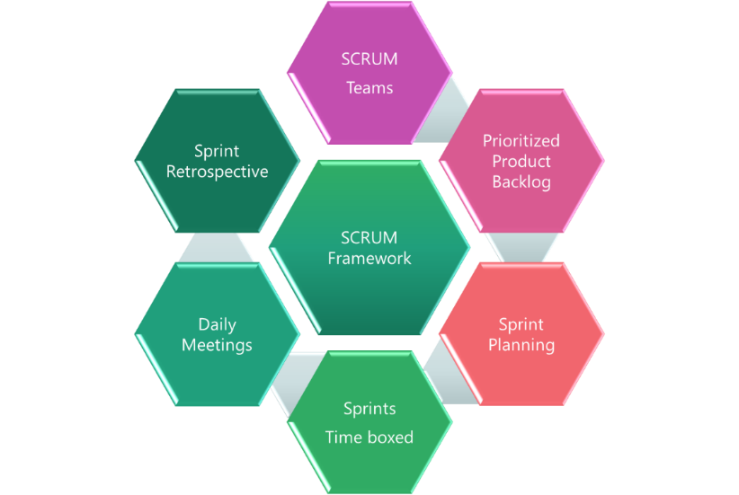

2-week sprint cadence would be followed and there would be a demo at the end of each sprint.

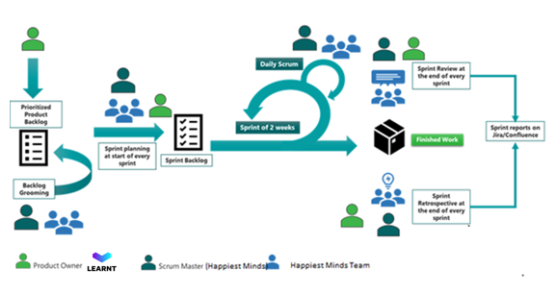

## Governance Model

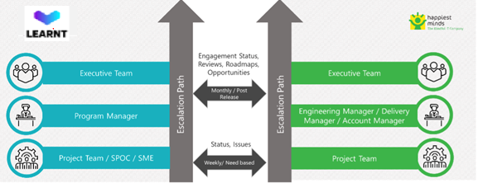

* Happiest Minds will nominate a Project Manager who will plan and oversee the engagement
* The overall communication and meetings between the team includes issues and escalations will be taken up in the meetings that will be held between Happiest Minds and LEARNT Global.
* Issues not resolved at the level of the engagement and delivery manager will be escalated to the joint leadership team.

## Project Communication Model

Happiest Minds proposes the following project-related communication and their frequency:

* Weekly Status Report shall be shared with LEARNT Global at the end of each week along with the planned set of activities for next week
* Weekly sync up meeting between the LEARNT Global and Happiest Minds project teams to review the progress of the project
* End of engagement Business review meeting for overall engagement update and opportunity discussion which can be attended by LEARNT Global Sponsor, Executives & respective Directors.

## Risk and Mitigation Plan

| **S. No** | **Risk** | **Mitigation** |
| --- | --- | --- |
| 1 | Delay in requirements or clarifications | Will be taken care as per section 5.5 |
| 2 | Change in scope after clarifications or feedback | Will be taken care as per section 5.5 |

## Execution Schedule and Deliverables

The delivery schedule is based on the requirements outlined in Section 3. Any changes in the project's scope are expected to impact cost and schedule.

The project is estimated to be executed in **9 weeks**. Happiest Minds proposes to execute the project in sprints. Every sprint will be followed by a Sprint Demo. The project plan in terms of what will be delivered in each sprint will be agreed upon with LEARNT Global before the start of the project.

Following is an indicative plan for the implementation, a detailed one shall be arrived at within the 1st week of the project start and shared with all stakeholders.

**Assume Project Start Date: (T)**

|  |  |  |  |
| --- | --- | --- | --- |
| **Milestone** | **Due Date in Weeks** | **Owner** | **Deliverables** |
| Project Kickoff | T | Happiest Minds |  |
| Discovery | T + 1 | LEARNT Global & Happiest Minds | Requirements and clarifications |
| Infrastructure | T+3 | LEARNT Global & Happiest Minds | CloudFormation Templates, CICD Pipeline for Infra and creating the infrastructure |
| Application/Microservice  Deployment | T+5 | LEARNT Global & Happiest Minds | Docker Compose file and CICD pipeline for each apps/microservices and Docker deployment |
| Security | T+6 | LEARNT Global & Happiest Minds | Implement the Secret Manager configuration, IAM Users/Roles and Permissions |
| Monitoring and Alerts | T+8 | Happiest Minds | New Relic and Cloud Watch setup for both infra and application. Alert configuration for issues and metrics. |
| KT Documents | T+9 | Happiest Minds | Documentation and KT |

## Change Request Management

Changes to the scope will mean any of the following:

* Change introduced in the application between the proposal and the actual implementation or during the implementation.
* Any changes to the scope of the project as detailed in section “In Scope”
* Invalidation of any of the assumptions detailed in section “Assumptions”
* Any change to the terms and conditions as defined in section “Commercials”
* Non-fulfillment of any of the dependencies detailed in the sections “Dependencies”
* Any delay that happens to the schedule can be attributed to LEARNT Global.

In case of a change request, the scheduled end date for this Project and/or the fees associated may change. Whenever a change is identified, it will be managed as per the below process:

* For any changes to the scope, either LEARNT Global or Happiest Minds will submit a Change Request
* Happiest Minds will issue a Change Order providing the impact of the change to the schedule and/or fees
* LEARNT Global SPOC will review along with Happiest Minds SPOC and mutually agree to either approve or cancel the change order
* Changes will be implemented only after LEARNT Global SPOC approval and signing of the change order form by both the Parties
* For any LEARNT Global dependencies that are not met or issues that are not resolved, which could impact the schedule – Happiest Minds Project Manager will complete a Change Order and inform the LEARNT Global SPOC.

## Acceptance Criteria

* Acceptance review will be carried out by LEARNT Global team and supported by Happiest Minds
* The acceptance criteria will be approval of wireframes.

# Commercials

## Hourly Rate

Happiest Minds proposes an hourly rate of **AU$ 63 per person per hour** for its senior DevOps consultant engaged with LEARNT Global on this project.

## Payment Terms

* Happiest Minds shall charge for the services rendered by the resources on a Time & Material basis, at the end of each month.
* Any clarification regarding an invoice shall be brought to Happiest Minds’ notice by the client within 5 working days from the date of receipt of the invoice.
* All undisputed invoices shall be paid by the client within 45 days from the date of receipt of the invoice.
* For invoices that are not paid within the standard payment terms, Happiest Minds reserves the right to charge interest as per applicable commercial interest rates.

## Commercial terms and conditions

* **Currency:** Prices quoted above are in Australian Dollars (AUD or AU$).
* **Taxes:** The rates quoted above are exclusive of all taxes and duties applicable for such services in Australia, such as GST.
* **Work hours:** 8.75 hours of work have been considered for each working day offshore between 9AM – 6PM IST. Onsite working days shall be 8 hours during the regular work hours at the client location. Work outside of normal business hours or on public holidays shall carry an uplift of 15% on the rates for offshore and onsite.
* **Travel for onsite assignments:** If the offshore resources do need to travel to onsite client locations outside India on short durations < 90 days, the client will need to bear the cost of economy class return airfare from our offshore location to the client location, visa processing charges and applicable per diems per day of stay (including weekends & public holidays). This will be in addition to the offshore rates applicable as per the above table. Happiest Minds shall provide the applicable per diems based on the destination.

Onsite rates for services > 90 days shall be provided on a case-by-case basis.

* **Hardware and Software Requirements:** The rates proposed by Happiest Minds include the cost of providing a standard desktop and shared internet bandwidth. The rates do not include the cost of any special purpose hardware / software or dedicated network links required for project execution. Any such costs shall be paid for by the client at actuals.
* **Validity:** This offer is valid for 30 days from the date of submission.

# GENERAL LEGAL TERMS AND SOW ACCEPTANCE

* Any changes to this SOW would be initiated by business change request (“CR”). Once discussed and mutually agreed, the CR would be approved and signed as an addendum to this SOW.
* During the term of this SOW and for one (“1”) year thereafter, neither party shall solicit, directly or indirectly, any employee of the other party who was involved in the provision or receipt of the services. This clause shall not restrict a party from hiring employees of the other party who apply unsolicited in response to a general advertising or recruitment campaign.
* In no event, will either party be liable to the other for any indirect, special, consequential, punitive or incidental damages or loss of revenue, loss of data or loss of business or profits, however caused, even if advised of the possibility of such damages and the maximum aggregate liability (whether in contract, tort (including negligence and wilful misconduct)) of either party to the other, regardless of the form of claim, shall be limited to the aggregate fees paid or payable to Happiest Minds by the Client under the SOW in the preceding twelve months of the event giving rise to such claim.
* Neither party shall, without the express written consent of the other, make public or otherwise directly or indirectly reveal the contents or existence of this SOW or any confidential information exchanged between parties except to their employees/consultants/advisors who shall undertake a similar duty of confidentiality.
* This SOW shall be construed and governed by the laws of Australia, with legal jurisdiction as New South Wales.

# Contact Information

For additional information or clarifications relating to this document, pls contact:

|  |  |
| --- | --- |
| **Name of the Contact** | Soumendu Mukhopadhyay |
| **Designation** | General Manager and Head of PES - APAC |
| **Email id** | [soumendu.m@happiestminds.com](mailto:soumendu.m@happiestminds.com) |
| **Phone Number** | +61 451 630 751 |
| **Name of the Company** | Happiest Minds Technologies Limited |
| **Address of Company** | Registered office: #53/1-4, Hosur Main Road, Madivala,  Next to Madivala Police Station, Bengaluru-560068, Karnataka, India  Australian Office: Level 20, Tower 2, Darling Park, 201, Sussex Street, Sydney, NSW 2000, Australia |
| **Website** | <https://www.happiestminds.com/> |

# TERMINATION

* The SOW may be terminated by either party without cause upon thirty (30) days prior written notice to the other party.
* The SOW may be terminated by either party:
  + with thirty (30) days’ notice, if the other party breaches the terms of Statement of Work and such breach remains uncured for a period of thirty (30) days or any other mutually agreed time frame or immediately, in following events (i) the other party becomes or applies for insolvency, bankruptcy, reorganization or liquidation, (ii) a receiver is appointed for its business or assets or applied for by the other party, (iii) a third party files, or has filed an action under (i) or (ii) above against the other party and such action is not dismissed within ninety (90) days, (iv) an order for relief under the applicable bankruptcy or insolvency law has been issued or applied for by other party, (v) the other party commits a material breach under the SOW, which breach cannot be cured.
  + Additionally, the Happiest Minds shall reserve the right to terminate this SOW with no further notice in the event of non-payment of the Fees or expenses due if such breach is not cured within fifteen (15) days of receiving notice of breach from Happiest Minds.
* Happiest Minds shall be paid Fees or expenses or both relating to completed and accepted Milestones as well as for the Milestone for which work is on-going on pro-rata basis up to the effective date of termination.

IN WITNESS WHEREOF, the parties have signed the SOW as of the Effective Date.

The parties have caused their duly authorized representatives to execute the SOW as of the date set forth below:

|  |  |
| --- | --- |
| For Learnt Global Pty Ltd | For Happiest Minds Technologies Limited |
| Name: | Name: Praveen Darshankar |
| Title: | Title: VP – Legal & Company Secretary |
| Date: | Date: |

**Contact Us**

**Corporate Office**

Happiest Minds Technologies Limited

#53/1-4, Hosur Main Road

Madivala, (Next to Madivala Police Station), Bengaluru-560068, Karnataka, India

Phone: +91 80 61960300, +91 80 61960400

Fax: +91 80 6196 0700

Email: [contactus@happiestminds.com](mailto:contactus@happiestminds.com)

Web: [www.happiestminds.com](http://www.happiestminds.com)

Our presence extends across United States

United Kingdom, Canada, Australia, UAE, and The Netherlands.



**About Happiest Minds**

Happiest Minds is a next generation IT services company combining unparalleled experience, comprehensive capabilities across all industries and business roles, and forward-thinking advisory capabilities. Happiest Minds collaborates with clients to help them differentiate and win with a unique blend of solutions and services based on the core technology pillars of cloud computing, social computing, mobility, and analytics. Founded in 2011, Happiest Minds is headquartered in Bangalore, India and offices in the USA and UK. For more information visit: [www.happiestminds.com](http://www.happiestminds.com)



**©2017 Happiest Minds Technologies Ltd. All Rights Reserved.**